ASSIGNMENT 2
IFCONFIG ROLLNO:64

1.
ifconfig:
ifconfig displays the status of the currently active interfaces,used to configure network interfaces

example:
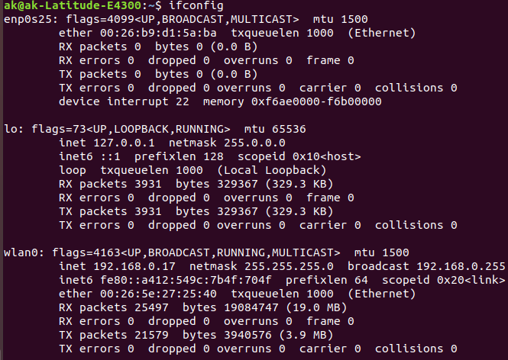

ifconfig -a:
it displays the status of all interfaces, even those that are down

example:
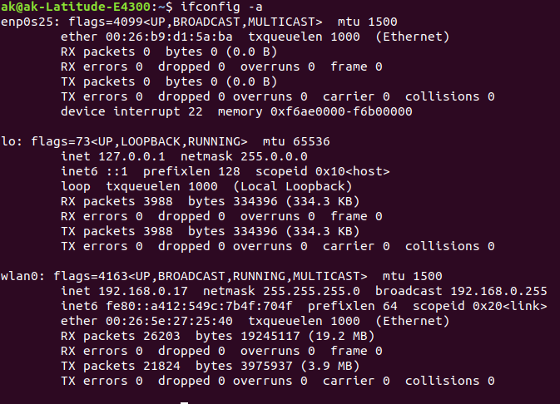

ifconfig <specific adapter>:
displays the status of specif network adapter

example
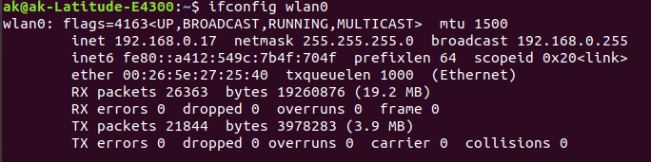

ifconfig <interface name> <ip address>
To Assign a IP Address to Network Interface

example:

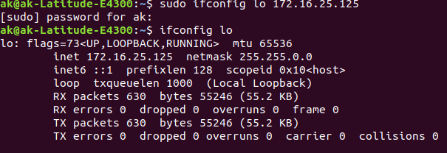
ifconfig <network interface> netmask <ip>
To Assign a Netmask to Network Interface

example:
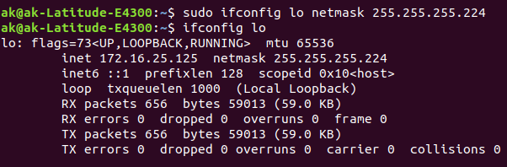
ifconfig <network interface> broadcast <IP>
To Assign a Broadcast to Network Interface

example:
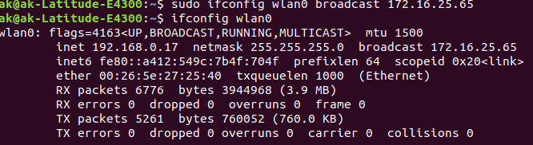

ifconfig <interface name> promisc
To Enable Promiscuous Mode
ifconfig <interface name> -promisc
To Disable Promiscuous Mode

example:
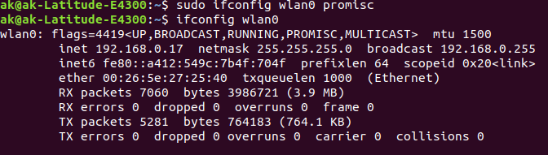

2.
ifdown:
To take a network interface down

ifup:
To bring a network interface up

example:
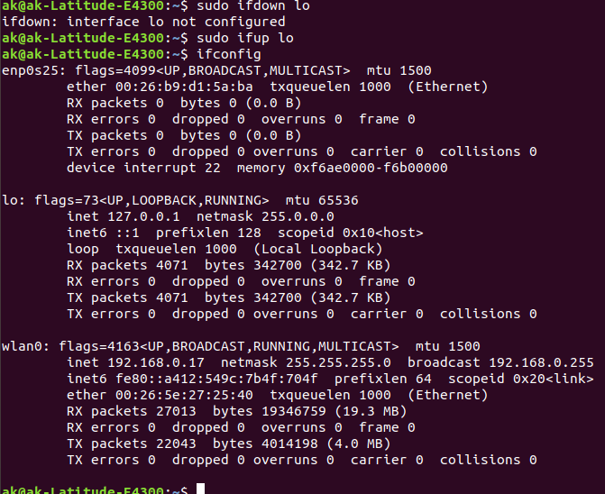
3.
route:
To show tor manipulate the IP routing table

example:
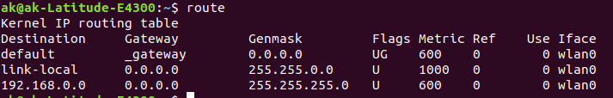

route add -net 10.10.10.0/24 gw <IP>
To add new route
route del -net 10.10.10.0/24 gw <IP>
To delete a route
route add default gw <IP>
Set a default gateway

4.
host:
DNS look up utility,give domain name gets ip address

example:
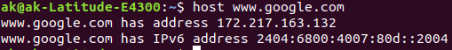

5.
netstat:
Print network connections, routing tables, interface statistics, masquerade connections, and multicast memberships

netstat -r:
Display the kernel routing tables

example:
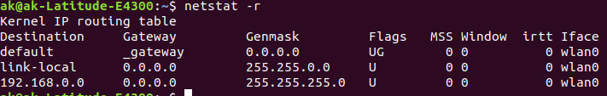

6.
ping:
Packet Internet Groper,send ICMP ECHO_REQUEST to network hosts

ping -c 5 <domain name>
exist after 5 number of requests

example:

7.
ip addr:
gives the ip address of each network interface

example:
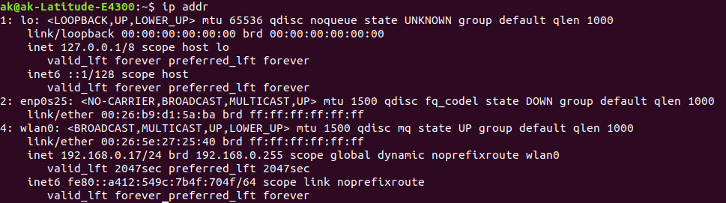
8.
# ifconfig <interface name> 192.168.50.5 netmask 255.255.255.0
Assigning an IP Address and Gateway to interface

example:
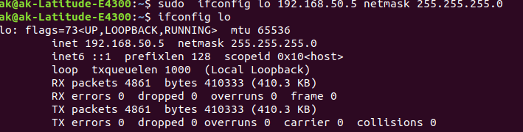
ifconfig <interface name> mtu <size>
changing mtu size

example:
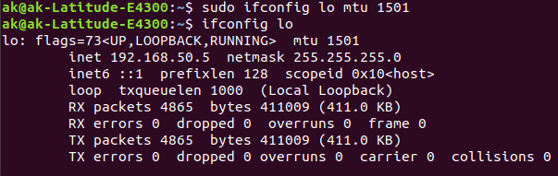
9.
hostname:
gives hostname

example:
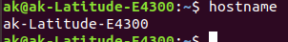

RESULT:
familiarized network interface commands and their uses by using ifconfig.

